**Lab 4: Low Pass Filter**

**Lab Report by: Talal Jawaid**

**Lab Session: Wednesday**

**Due Date of the Lab: 5/8/18**

**Date(s) of the lab: 4/11/18-4/18/18-4/25/18**

**Lab partner(s): Sergio Zavala and Amrit Singh**

1. **Introduction**

In this lab we became familiarized with low pass filters and how to implement them into circuits. This lab took three weeks and consisted of two main parts. The first part was to simply construct each of the four circuits. The circuits were the passive and active low pass filters, and another set of the same circuits but with a 1k ohm load resistor from Vin to Vout. We had to make four sets of measurements. We measured the Vin, Vout, and Phaseshift. We also calculated the theoretical gain, the measured gain and recorded the frequency at which the cut off was for the low pass filter. In the second part of the lab we used PSPICE to create the circuits that we created to see the graphs of certain variables. Then we compared the PSPICE values to the values we obtained experimentally, as well as the values we calculated for.

1. **Purpose**

The purpose of this lab is to familiarize us with low pass filters so that we can understand how to use them and where we can implement them in circuits. The low pass filter can be used to clean up a signal of noise where you can read a signal without worrying about issues like background noise affecting your values. We also learned the limitations of the low pass filters and the understanding that a low pass filter will only “clean” a signal up to a certain frequency. This can be solved by adjusting your low pass filter so that it cleans the signal up to the frequency that you want.

1. **Discussion and Results**

**Part1:**

**Procedure:**

First we constructed the circuits that we were required to construct. Then we connected the oscilloscope and used the wave generator feature of the oscilloscope so that we could create the input for the circuit. Then we used the measurement tools of the oscilloscope to determine Vin, Vout, and phaseshift between those two. We then slowly increased the frequency starting from 100Hz until the output was reduced to the .707 point.

**Data:**

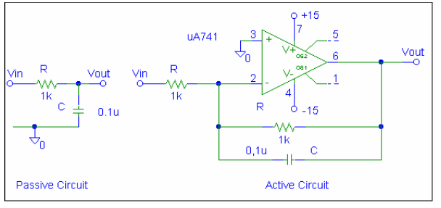

Part I: Passive Unloaded 100 Hz

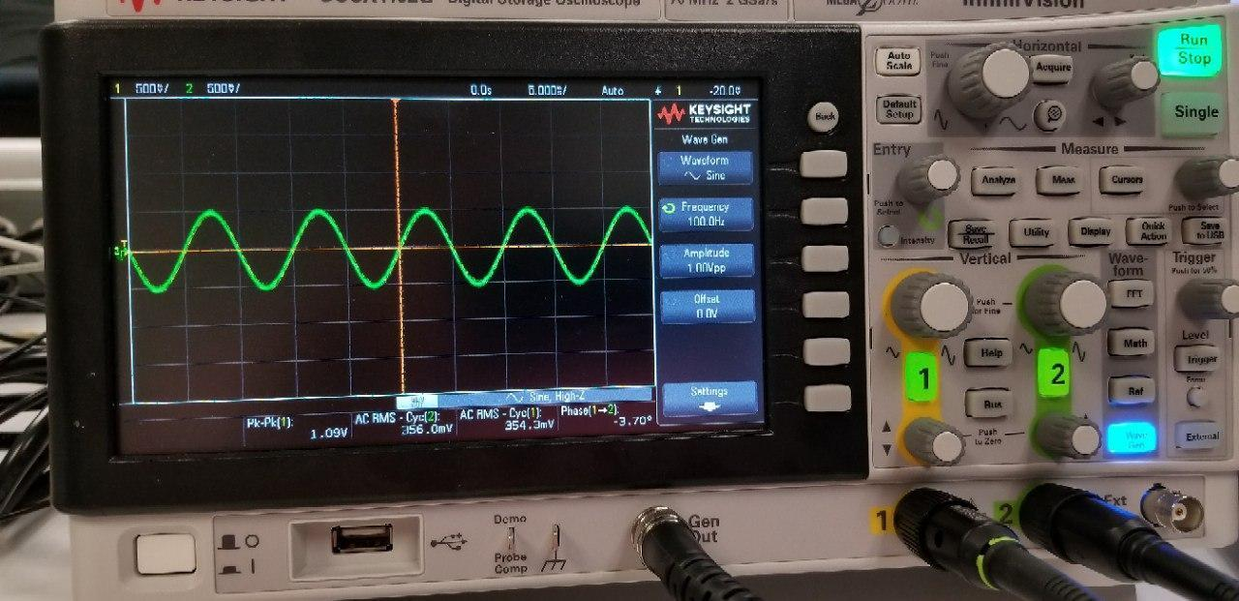

Part I: Active Unloaded / Waveform

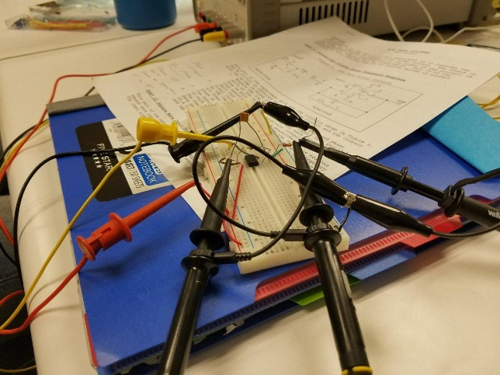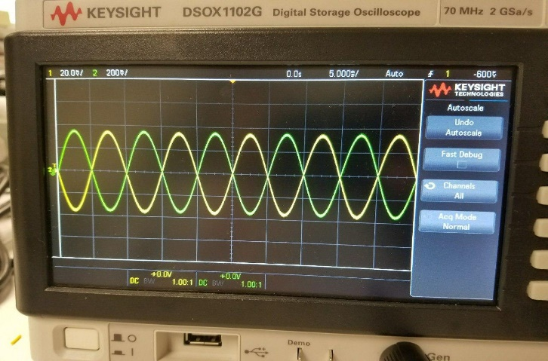

**PSPICE Results**

Passive Circuit Unloaded

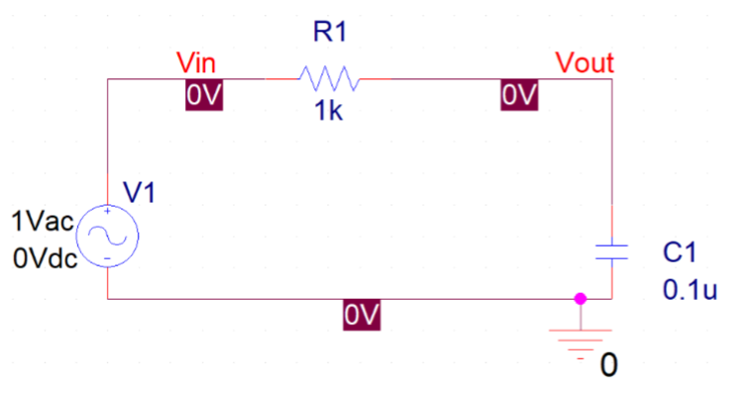

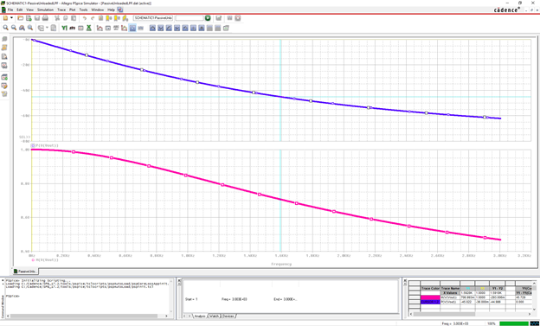

Passive Circuit and Graph Loaded 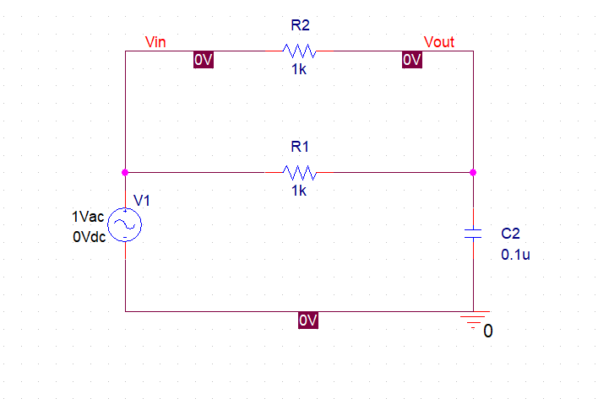

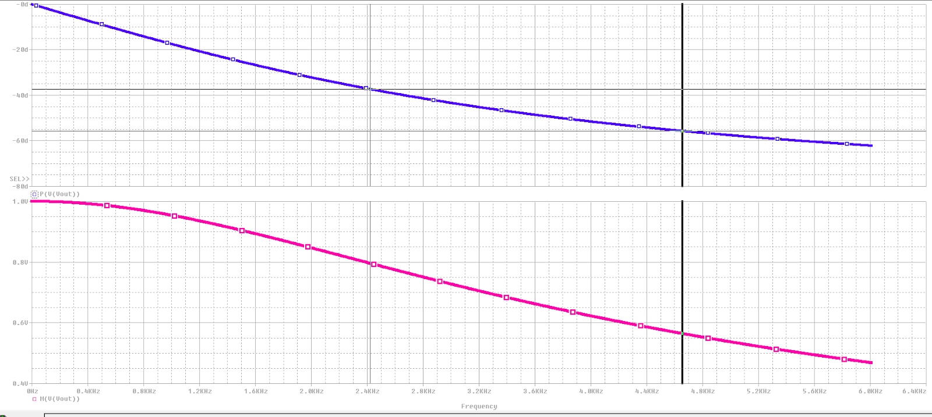

Active Circuit and Graph Unloaded

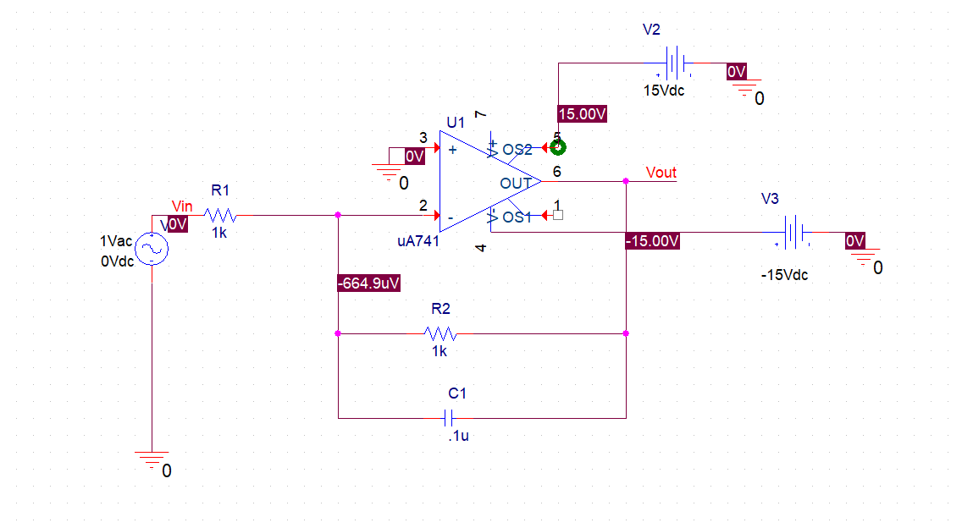

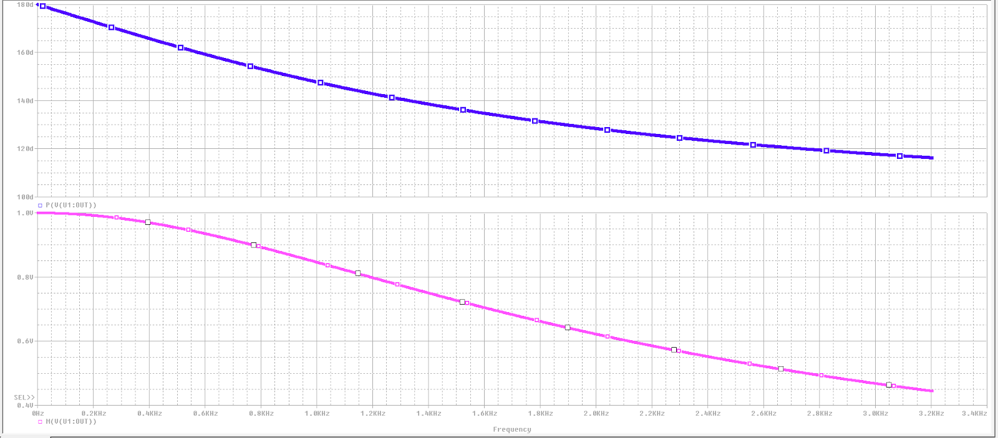

Active Circuit and Graph Loaded

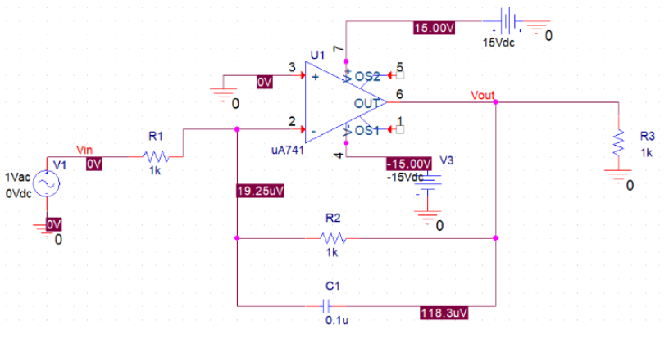

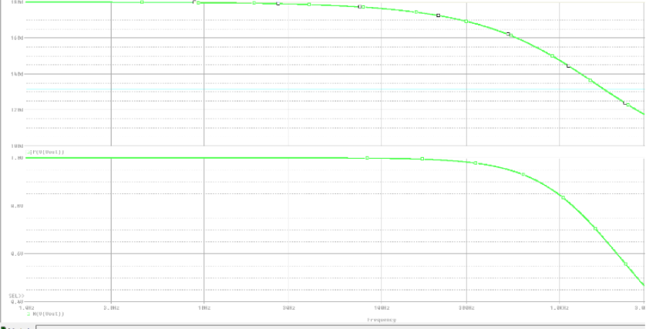

|  |  |  |  |  |  |  |  |  |
| --- | --- | --- | --- | --- | --- | --- | --- | --- |
|  |  | Vin | Vout | Theoretical Gain | Measured Gain | Phaseshift | Frequency |  |
| Passive Circuit |  | 356 mv | 354.2 mv | 1 | 0.995 | -3.5 | 100 Hz |  |
|  |  | 348.5 | 251.9 | 0.707 | 0.723 | -42 | 1.5KHz | (Cutoff Freq) |
| With 1k Resistor |  | 347.1 | 173.5 | 0.5 | 0.4998559493 | -0.5 | 100Hz |  |
|  |  | 344.3 | 123.5 | 0.3535 | 0.3586988092 | -41.2 | 3Khz | (Cutoff Freq) |
| Active Circuit |  | 246.5 | 246.5 | 0 | 0 | 0 | 100 |  |
|  |  | 246.5 | 174.5 | 0.707 | 0.7079107505 | 0 | 1.6Khz |  |
| With 1k Resistor |  | - | - | - | - | - | - | - |

(Data for the loaded Active Circuit was in an Excel file which was corrupted). Remaining data was recovered from Excel’s autorecovery feature.

**Part 2:**

**Procedure:**

For this part of the lab, we first had to find the Fourier series of the input Vin. Then we had to find the Fourier series of the output by putting the Fourier series of Vin through the RC circuit one term at a time. While we were able to construct the Fourier series of the input Vin, we were unable to figure out how to put together the Fourier series of the output Vout. We then had to use the function generator to create the same form as shown in Figure 2. We then took pictures of the wave forms of Vin and Vout, super imposed on top of each other. We made sure the DC offset was the same for both input and output waves. After this, we created the circuit using the Cadence Allegro design suite and then used PSPICE to simulate the circuit. We then input the initial values for VPULSE. We performed a transient analysis on the circuit. Then we used the Fourier analysis software to determine up to the eighth harmonic, what the Fourier series coefficients were.

**Data:**

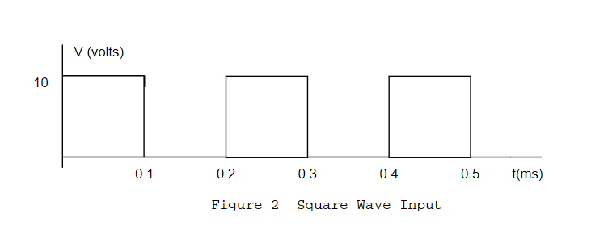

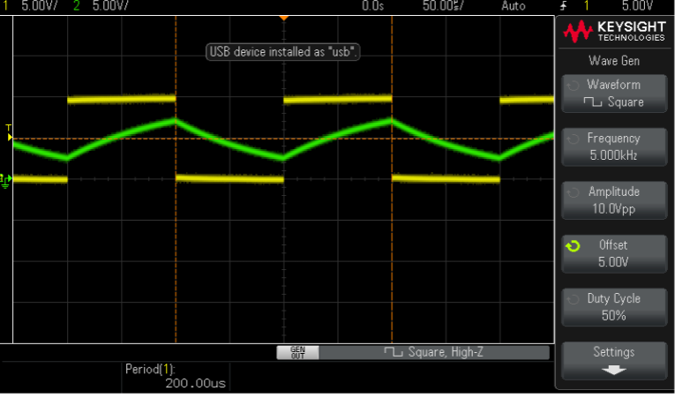

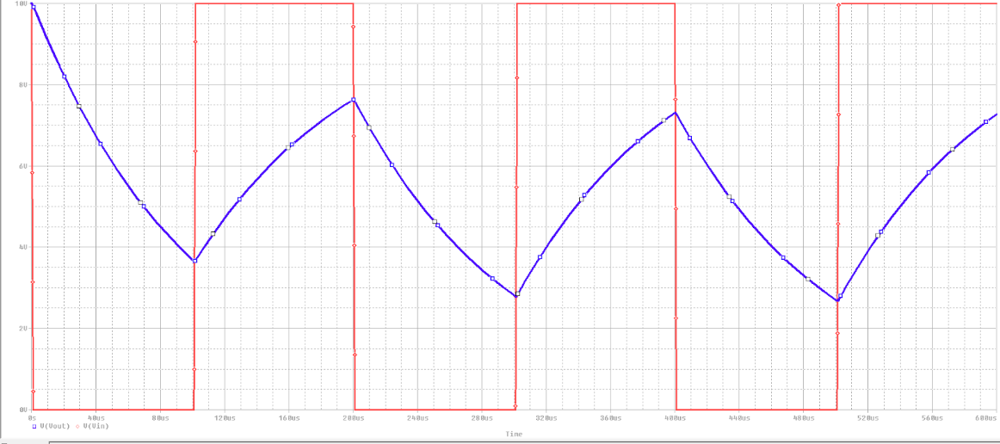

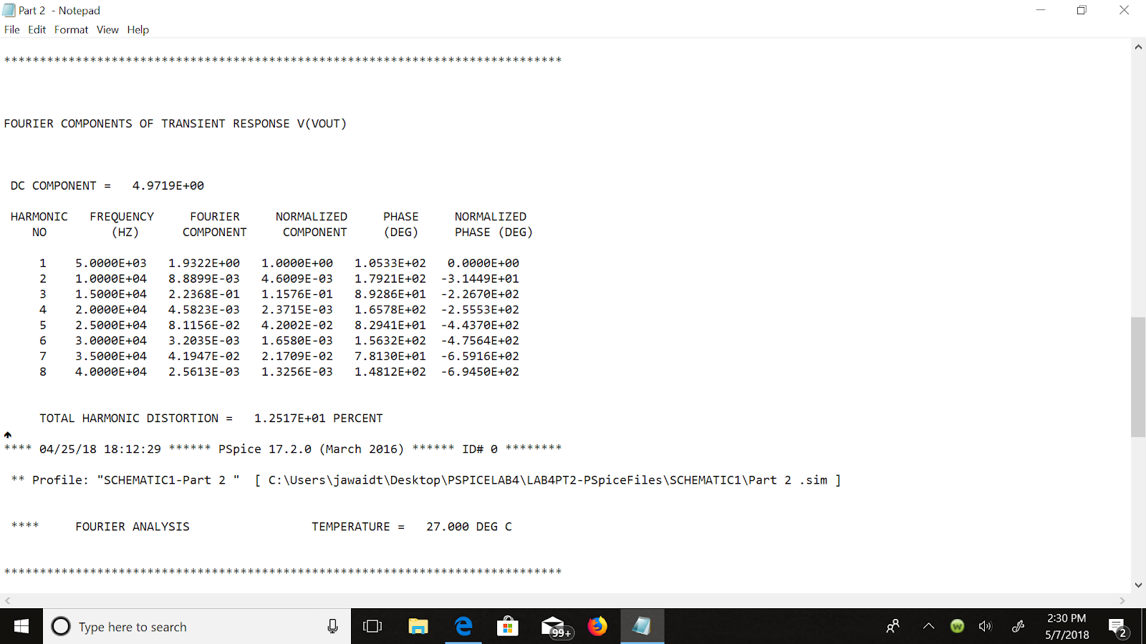

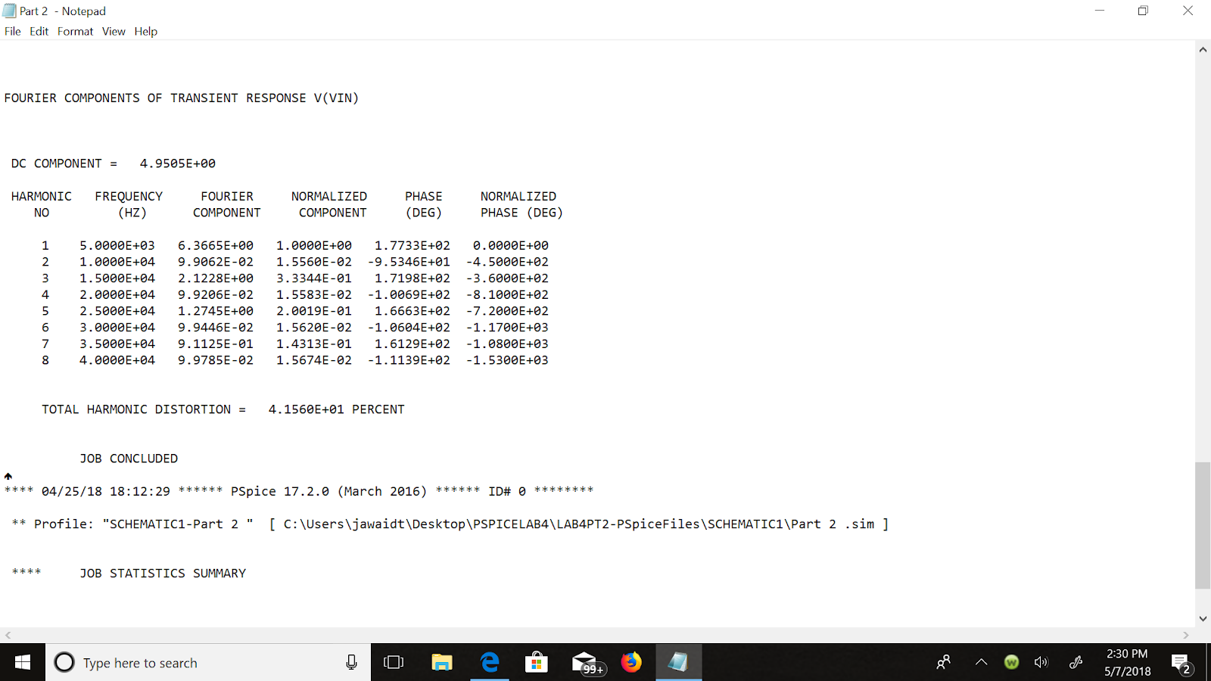

1. **Discussion**
2. **Compare the various gains and phase shifts found in Part 1.**

For the passive circuit, the gain without changing the frequency from the initial of 100Hz was .995. After modifying it to reach the theoretical gain of .707 (.707 point), the frequency was at 1.5Khz but the measured gain was .723 before we reached the cut off frequency. The phase shift initially was -3.5 and then it went to -42 after reaching the cut off frequency of 1.5Khz With the loaded passive circuit, the gain was .4998 while the theoretical was .5. The phase shift was about -0.5 degrees at the initial frequency of 100 Hz. After increasing the frequency to reach the cut off at 3 Khz, the theoretical gain was .3535 and the measured was .3589. The phase shift at that point was -41.2 degrees.

1. Compare the steady state response of the active circuit to the response of the passive circuit when a load is added.

Due to our issues with the excel file corrupting, we are unable to view the data from the active loaded circuit. As such, we can’t say for sure what the steady state response of the active loaded circuit was compared to the passive loaded circuit. We think that the active circuit would have a smaller phaseshift than the passive loaded circuit.

1. Compare the experimental output to the PSPICE simulated output for the square wave input of Part II.

The PSPICE simulated output for the square wave input was not the same for us as the one in our experiment. We could not pinpoint the issue with our waveform but it was curving in straight lines at what seemed like 45 degree angles. As such, it was not the same as the PSPICE simulated output. According to the lab instructor, the issue could possibly have been with the oscilloscope or with the way we set up our circuit. We believe that the issue was with the way the settings on the oscilloscope were set up because we had correct readings for our other circuits on a separate oscilloscope.

1. **Conclusion:**

In this lab we compared the different methods of implementing low pass filters, both active and passive. We tested these out using the 1k ohm resistor. We then performed the experiment to determine the cut off frequency for each low pass filter. In the second part of the lab, we constructed the Fourier series for the input and attempted to construct the Fourier series for the output. We used the Cadence Allegro design suite to construct the suite and then imported that into PSPICE so that we could simulate the circuit and obtain the waveform we were looking for. Using the Fourier Analysis tool, we were able to determine the coefficients for the Fourier series up till the eighth harmonic.